SPH3U0 **Analyzing a V-T Graph for Non-Uniform Motion**

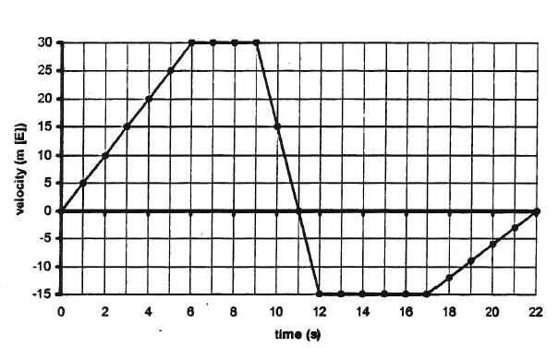**The graph below shows the motion of a soccer player running east and west on a field during a play. Use the graph to answer the questions below.**

**Velocity versus Time**

1) What is the velocity at :

|  |  |  |  |  |
| --- | --- | --- | --- | --- |
| 4.0 s? | 7.0 s? | 10.0 s? | 14.0 s? | 20.0 s? |

c) Over what time intervals is the player running west?

b) Over what time intervals is the player running east?

2) a) Over what time intervals is the player

running at a constant velocity?

3) **To find acceleration you take the ____________ of the v-t graph!**

**Determine the acceleration over the following intervals:**

|  |  |  |  |  |
| --- | --- | --- | --- | --- |
| **0-6.0 s:** | **6.0-9.0 s:** | **9.0s -12.0 s:** | **12.0s – 17.0 s:** | **17.0s -22.0s :** |

4) **To find the displacement over each time interval, you find the _______________ between the graph and the x-axis!**

Find the displacement over each time interval:

|  |  |  |  |  |  |
| --- | --- | --- | --- | --- | --- |
| **0-6.0 s:** | **6.0-9.0 s:** | **9.0s -11.0 s:** | **11.0s -12.0 s:** | **12.0s – 17.0 s:** | **17.0s -22.0s :** |

5)a) Find the player’s resultant displacement. (Hint: Add up all of the displacements!)

b) Find the player’s average velocity.